

A Minor Project - II Report on

SUPER MARKETING IN ADVANCED TECHNOLOGY

Submitted by

RAM PRAKASH S (927622BEE086) SAPREENA S (927621BEE099)

SRINIDHI B (927622BEE114)



DEPARTMENT OF ELECTRICAL AND ELECTRONICS ENGINEERING M.KUMARASAMY COLLEGE OF ENGINEERING
(An Autonomous Institution Affiliated to Anna University, Chennai) THALAVAPALAYAM, KARUR-639113.

DECEMBER 2023

M.KUMARASAMY COLLEGE Of ENGINEERING
(Autonomous Institution, Affiliated to Anna University, Chennai)

BONAFIDE CERTIFICATE

Certified that this Report title “SUPER MARKETING IN ADVANCED TECHNOLOGY” is the bonafide workof RAM PRAKASHS (927621BEE086),
SAPREENA S (927621BEE099) SRINIDHI (927622BEE114) who carried out the
work during the academic year (2023-2024) under my supervision. Certified further that to the best of my knowledge the work reported herein does not form part of any other project report.

SIGNATURE SIGNATURE
SUPERVISOR HEAD OF THE DEPARTMENT

Dr. J.Uma M.E., Ph.D., Dr.J.Uma M.E., Ph.D.,
Professor & Head Professor & Head

Department of Electrical and Electronics Engineering
Department of Electrical and ElectronicsEngineering

M.Kumarasamy College of M.Kumarasamy College of
Engineering, Karur Engineering, Karur

Submitted for Minor Project I (18EEP201L) viva-voce Examination held at M.Kumarasamy College of Engineering,Karur-639113 on ………………..

ii

DECLARATION

We affirm that the Minor Project report title “ SUPER MARKETING IN ADVANCED TECHNOLOGY” being submitted in partial fulfillment for the award of Bachelor of Engineering in Electrical and Electronics Engineering is the original work carried out by us.

REG.NO | STUDENT NAME | SIGNATURE
927621BEE086 | RAM PRAKASH S | ------------------------
927621BEE099 | SAPREENA S | ------------------------
927622BEE114 | SRINIDHI B | ------------------------

iii

VISION AND MISSION OF THE INSTITUTION
VISION

- To emerge as a leader among the top institutions in the field of technical education

MISSION

- Produce smart technocrats with empirical knowledge who can surmount theglobal Challenges.
- Create a diverse, fully-engaged, learner - centric campus environment to provide Quality education to the students.
- Maintain mutually beneficial partnerships with our alumni, industry and Professional associations.

DEPARTMENT OF ELECTRICAL AND ELECTRONICS ENGINEERING VISION
To produce smart and dynamic professionals with profound theoretical and practicalknowledge comparable with the best in the field.

MISSION

- Produce hi-tech professionals in the field of Electrical and Electronics Engineering by inculcating core knowledge.
- Produce highly competent professionals with thrust on research.
- Provide personalized training to the students for enriching their skills.

PROGRAMME EDUCATIONAL OBJECTIVES(PEOs)

- PEO1: Graduates will have flourishing career in the core areas of ElectricalEngineering and also allied disciplines.
- PEO2: Graduates will pursue higher studies and succeed in academic/research careers
- PEO3: Graduates will be a successful entrepreneur in creating jobs related toElectrical and Electronics Engineering /allied disciplines.
- PEO4: Graduates will practice ethics and have habit of continuous learning fortheir success in the chosen career.

PROGRAMME OUTCOMES(POs)
After the successful completion of the B.E. Electrical and Electronics Engineering degree program, the students will be able to:

PO1: Engineering Knowledge: Apply the knowledge of mathematics, science, engineering fundamentals, and an engineering specialization to the solution of complex engineering problems.

PO2: Problem Analysis: Identify, formulate, review research literature, and analyze complex engineering problems reaching substantiated conclusions using first principles of mathematics, natural sciences, and engineering sciences.

PO3: Design/Development of solutions:
Design solutions for Complex engineering problems and design system components or processesthat meet the specified needs with appropriate consideration for the public health and safety,and the cultural, societal and environmental considerations.

PO4: Conduct Investigations of complex problems: Use research-based knowledge and research methods including design of experiments, analysis and interpretation of data, and synthesis of the information to provide valid conclusions.

PO5: Modern Tool Usage: Create, select, and apply appropriate techniques, resources, and modern engineering and IT tools including prediction and modeling to complex engineering activities with an understanding of the limitations.

PO6:The Engineer and Society: Apply reasoning in formed by the contextual knowledge to assess societal, health, safety, legal and cultural issues and the consequent responsibilities relevant to the professional engineering practice.

PO7:Environment and Sustainability: Understand the impact of the professional engineering solutions in societal and environmental contexts, and demonstrate the knowledge of, and need for sustainable development.
PO8: Ethics: Apply ethical principles and commit to professional ethics and responsibilities and norms of the engineering practice.

PO9: Individual and Team work: Function effectively as an individual, and as a member orleader in diverse teams, and in multi-disciplinary settings.

PO10: Communication: Communicate effectively on complex engineering activities with the engineering community and with society at large, such as, being able to comprehend and write effective reports and design documentation, make effective presentations, and give and receive clear instructions.
PO11: Project Management and Finance: Demonstrate knowledge and understanding of the engineering and management principles and apply these to one’s own work, as a member and leader in a team, to manage projects and in multi-disciplinary environments.

PO12: Life-long learning: Recognize the need for, and have the preparation and ability to engage in independent and life-long learning in the broadest context of technological change.

PROGRAM SPECIFIC OUTCOMES(PSOs)
The following are the Program Specific Outcomes of Engineering Students:
- PSO1: Apply the basic concepts of mathematics and science to analyse and design circuits,controls, Electrical machines and drives to solve complex problems.
- PSO2: Apply relevant models, resources and emerging tools and techniques to providesolutions to power and energy related issues & challenges.
- PSO3: Design, Develop and implement methods and concepts to facilitate solutions forelectrical and electronics engineering related real world problems.

Abstract (Key Words) | Mapping of POs and PSOs
LCD Display,coder,OR code scanner  ,arduino board,lcd display technology used in trolley in connection. | PO1,PO2,PO3,PO4,PO5,PO6,PO7, PO8,PO9,PO10,PO11,PO12,PSO1, PSO2,PSO3

ACKNOWLEDGEMENT

Our sincere thanks to Dr.K.Ramakrishnan B.E, Chairman of M.Kumarasamy College of Engineering for providing extra ordinary infrastructure, which helped us to complete the Minor project in time.

It is a great privilege for us to express our gratitude to our esteemed Principal Dr.BS.Murugan M.Tech., Ph.D., for providing us right ambiance for carrying out the project work.

We would like to thank our Head of the Department Dr.J.Uma M.E., Ph.D., Department of Electrical and Electronics Engineering, for their unwavering moral support throughout the evolution of the project.

We would like to express my deep gratitude to our Minor Project Guide
Dr.J. Uma M.E., Ph.D., Professor & Head , Department of Electrical and Electronics Engineering, for his constant encouragement, kind co-operation, valuable suggestions and support rendered in making our project a success.

We offer our wholehearted thanks to our Minor project coordinator Dr.B. Rajesh kumar M.E., Ph.D., Assistant Professor, Department of Electrical and Electronics Engineering, for his constant encouragement, kind co-operation and valuable suggestions for making our project a success.

We are glad to thank all the Faculty Members of Department of Electrical and Electronics Engineering for extending a warm helping hand and valuable suggestions throughout the project.

Words are boundless to thank Our Parents and Friends for their constant encouragement to complete this Minor project successfully

ABSTRACT

The Smart Shopping Cart project aims to revolutionize the traditional shopping experience by integrating advanced technologies to create a more efficient and user- friendly retail environment.This system leverages Internet of Things (IoT) and artificial intelligence to enhance the functionality of shopping carts, providing both customers and retailers with innovative features. Key Features of the Smart Shopping Cart System. Automated item tracking, Intelligent shopping assistance Automated Item Tracking: The shopping cart is equipped with RFID (Radio-Frequency Identification) or NFC (Near Field Communication) technology to automatically identify and track items as they are placed into or removed from the cart. This feature eliminates the need for manual bar code scanning and enhances the speed and accuracy of the shopping process. Intelligent Shopping Assistance: An integrated display on the cart provides real-time product information, including prices. Virtual Shopping Lists Customers can create and manage virtual shopping lists through a mobile app, and the cart intelligently guides them through the store to locate items efficiently.The system can optimize the shopping route to save time and enhance the overall shopping experience. Contact less Payment Integration: Seamless integration with digital payment systems allows customers to complete transactions directly from the shopping cart, reducing checkout time and enhancing convenience.Payment information is securely processed, providing a friction less payment experience. Anti- Theft Measures: The system includes anti-theft features such as weight sensors and RFID/NFC validation to ensure that all items are properly scanned and paid for before leaving the store. Alarms and alerts are triggered for any discrepancies, enhancing security.Data Analytics for Retailers: Retailers have access to analytics and insights derived from customer shopping patterns, helping them optimize store layouts, product placements, and promotions. The system contributes to data-driven decision- making for marketing strategies.

Survey form sample

CHAPTER 1
SURVEY FORM ANALYSIS

NAME AND ADDRESS OF THE COMMUNITY:
R.Rajasekar ,Ravi super market ,karur.

AGE GROUP :
36 Years to 50 years

DISCUSSION :
  - What? (Define the problem)
During the bill section the customers rejecting the some productsas side a table.

Why? (Reason for the problem occurrence)
The consumers does not know the exact amount and they do not have efficient amount to buy the products.

When? (when the problem began or first noticed)
While the consumer are purchasing in the super market.

Where? (Place of the problem) first occurrence or sighting)
While I am purchasing the stationery things in super market I noticed the problem including me and family members.

Who? ( The person or thing that the problem effects)
The problems affects to the consumer

How (The sequence of events that resulted in the problem)
If have been rectified in the super marketing in advanced technology by counting the amount in trolley itself

Signature of the surveyee

- Which? (People have attempted to solve the issue)
Yes

Does the problem appear to have only one possible solution?
Yes, it is the only one solution in this method.

Work plan of the project
To create a device which intimate the customer to purchase the products
easily

Final Solution
The final solution is the customer can now easily calculate the amount of product while purchasing in trolley itself by qr scanner which is placed n the trolley which will display in lcd display board and this instruments were connected in the trol

Chapter 1.2

SURVEY FORM ANALYSIS

- Name and address of the community:
R.Rajasekar ,Ravi super market ,karur.

Problem identification :
Customers are facing so many problem in pay section in super market due to they don’t know the exact amount of the product which they have taken by using the project method we can rectify these problem .

CHAPTER 2 LITERATURE REVIEW
Paper1 : SMART SHOPPING CART WITH AUTOMATIC BILLING SYSTEM THROUGH RFID AND ZIGBEE
Authors : P. Chandrasekar, T.Sangeetha
Published in : International conference on information communication and embedded systems ( ICICES2014)
Inference: This paper suggests a method that is based on the RFID and ZigBee which creates an automated central billing system for the shopping malls. eliminating the queues and displaying the real-time price of the items in the cart.

Paper2: RFID BASED ON SMART SHOPPING AND BILLING
Authors : Zeeshan ali, prof.reena sonkusare
Published in : IEEE conference 2013
Inference : In this paper, more utilization of LCD like removing the item by cancel button on LCD implemented. It explains how to access real-time information about the diverse products inside the shopping cart.

paper3: INNOVATIVE SHOPPING CART FOR SMART CITIES
Authors: Prasiddhi k, Dhanashree , H.Gawali
Published in : IEEE Conference 2017
Inference : The proposed system consists of some new smart features incorporated compared to other systems. Here provision is made for a truly beneficial budget setting. Customers will get the real time statistics/condition/information of the product which will ultimately help them to choose a best suited product for their needs.

Paper 4: AUTOMATION PRODUCT DETECTION AND SMART BILLING FOR SHOPPING USING LIGHT-FIDELITY
Authors : Ezhil Azhagan , R.Adithya, Y.L.Burhanuddin , F.charles
Published in : IEEE Conference 2016
Inference : It has features incorporated with automatic recognition of products by means of optical fibers using LiFi technology. The payment is processed through mobile bankingomoney payment and therefore the cart system can verify the products and complete the transaction successfully.

DESCRIPTION
A smart shopping cart is an innovative concept that combines technology with traditional shopping to enhance the overall shopping experience. The primary goal of a smart shopping cart is to streamline the shopping process, improve efficiency, and provide a more convenient and enjoyable experience for consumers. A description of the key features and components that could be included in a smart shopping cart project. Automatic Item Recognition: As items are placed in the cart, the smart system can automatically recognize and add them to the cart's digital inventory.The cart is equipped with a touchscreen interface that allows users to interact with the system. Users can view their shopping list, check prices, and access information about products through the cart's interface Bar code Scanner: A built-in bar code scanner allows users to scan items for detailed their smartphones with the smart cart through a dedicated mobile app. The app may provide features such as creating shopping lists, receiving personalized promotions, and tracking purchases. Automated Checkout:The smart cart can facilitate a seamless checkout process .Integrated payment options allow users to pay directly from the cart, reducing the need to wait in traditional checkout lines. Product Recommendations: Based on the user's purchase history and preferences, the smart cart can suggest additional products to enhance the shopping experience. Real-Time Analytics: The system can provide real-time analytics to store managers, helping them understand customer behaviour , popular products, and optimize inventory management. Implementing a smart shopping cart system can significantly enhance the efficiency of the shopping process, improve customer satisfaction. It is also improved many times according to requirements of sellers and customers. It does the same work that is calculating the bill, gives it to the customer and maintain proper database. They are accurate in calculation and printing, they also generate. The billing system is built to help supermarkets calculate and display bills and serve the customer in a faster and efficient manner. This software project consists of effective and easy

PROJECT KIT PHOTO GRAPH

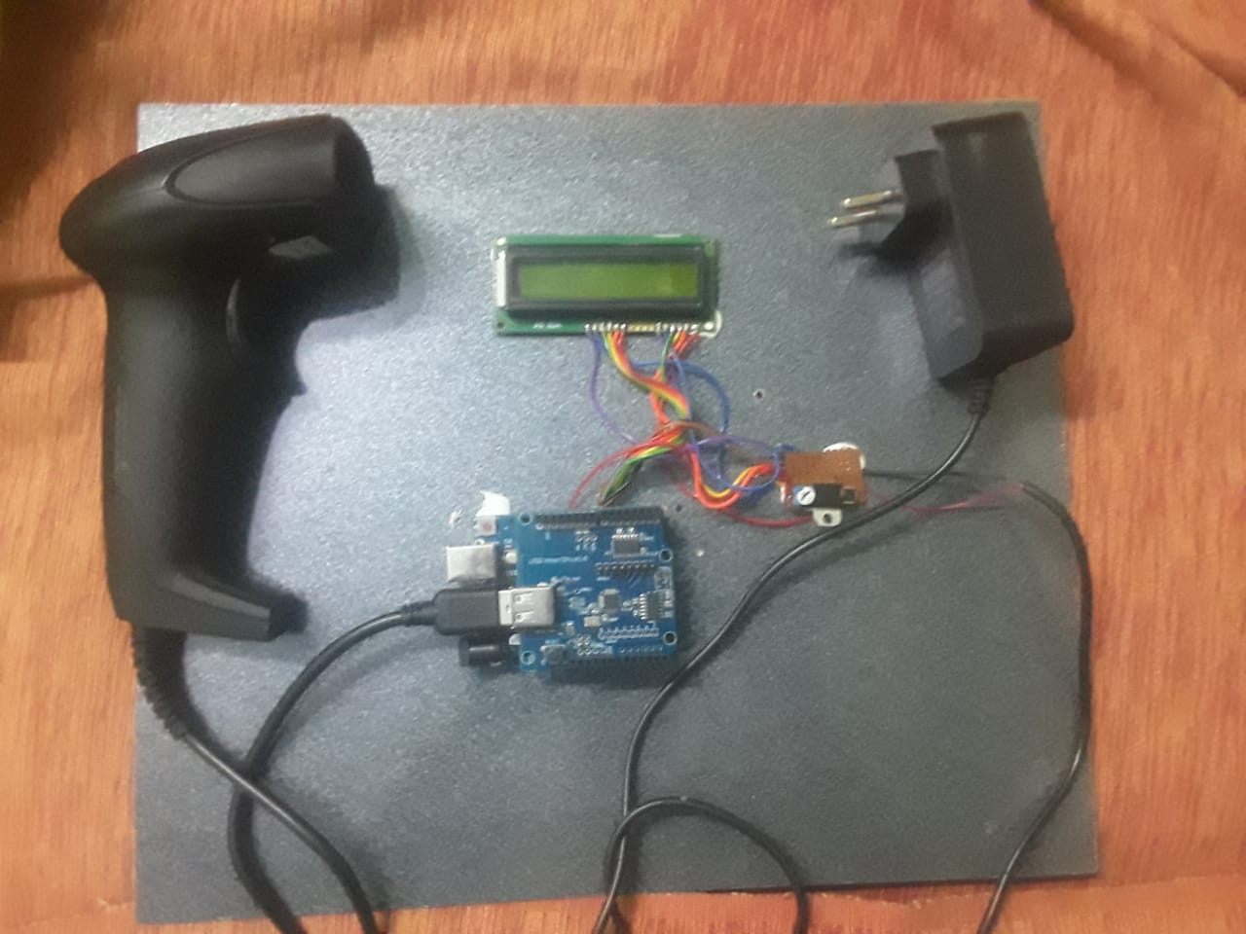

PROPOSED METHODOLOGY

3.1 BLOCK DIAGRAM

LCD DISPLAY OUTPUT AURDINO BOARD

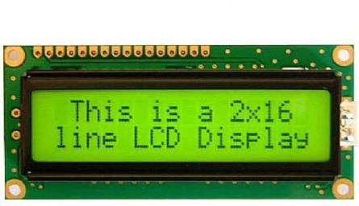

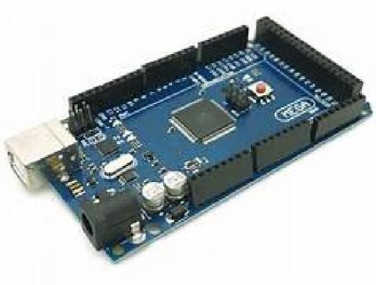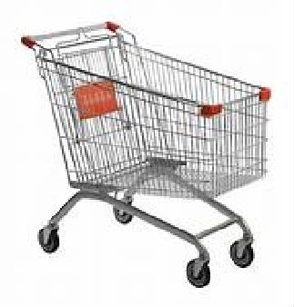TROLLEY

PROCESSING UNIT
QR SCANNER

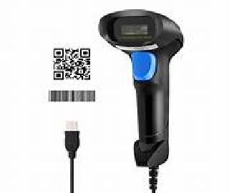
INPUT

CHAPTER 3

3.3 COST ESTIMATION

S.NO | COMPONENTS DESCRIPTION | QUANTITY | COST
1. | Trolley (From reuseable material) | 1 | 200
2. | QR code scanner | 1 | 1300
3 | LCD display board | 1 | 255
4. | Arduino components | 1 | 813
 | TOTAL |  | 2568

CHAPTER 4
FUTURE SCOPE & ITS IMPLEMENTATION PLAN

AI-Powered Recommendation System:
Uses machine learning algorithms to analyze people's preferences, purchasing history and behavior.
Increase sales and sales by sending personalized recommendations via mobile app or in-store.444

Computer Vision for Seamless Payment:
Integrated computer vision technology for seamless or hassle-free payment.
The automatic system allows quick and easy payment by identifying and counting the items in the customer's shopping cart.

IoT integration for shopping engagement:
Use Internet of Things (IoT) devices to create a connected shopping experience. Smart shelves with sensors can monitor and restock product levels, reducing out-of- stocks.

Mobile Apps to Increase Engagement:
Create feature-rich mobile apps that leverage augmented reality (AR) for virtual tryons or product demonstrations.
Location-based services can offer customers personalized promotions and discounts as they browse the store.

Blockchain supports chain transparency:
Use blockchain to improve chain visibility and traceability.
Customers can verify product authenticity, transparency and trust in the supply chain.

Data Analytics for Business Insights:
Use advanced analytics tools to analyze customer profiles, purchasing patterns, and store performance.
The knowledge gained can enable better decisions, improve inventory management, and improve overall business performance.444

Speech and Natural Language Processing (NLP):
Combining speech recognition and NLP for hands-free marketing. Customers can use voice commands to find products, get information or add products to the shopping list.

Robot Assistance:
Explore the use of robots to perform tasks such as managing inventory, stocking shelves, or providing customer service.
Robots can increase productivity and create a futuristic economy.

Cyber Security Measures:
Use strong cyber security measures to protect customer information and ensure the security of the store.
Since this project involves the processing of sensitive information, it is important to pay attention to information security.

Sustainability Initiatives:
Consider environmentally friendly behaviors such as reducing waste packaging or encouraging product choice.
Use technology to educate consumers about the environmental impact of their purchases.Continuous monitoring of the progress of technology and consumer products is important for timely updating and improvement of smart products,.

IMPLEMENTATION PHOTOGRAPH
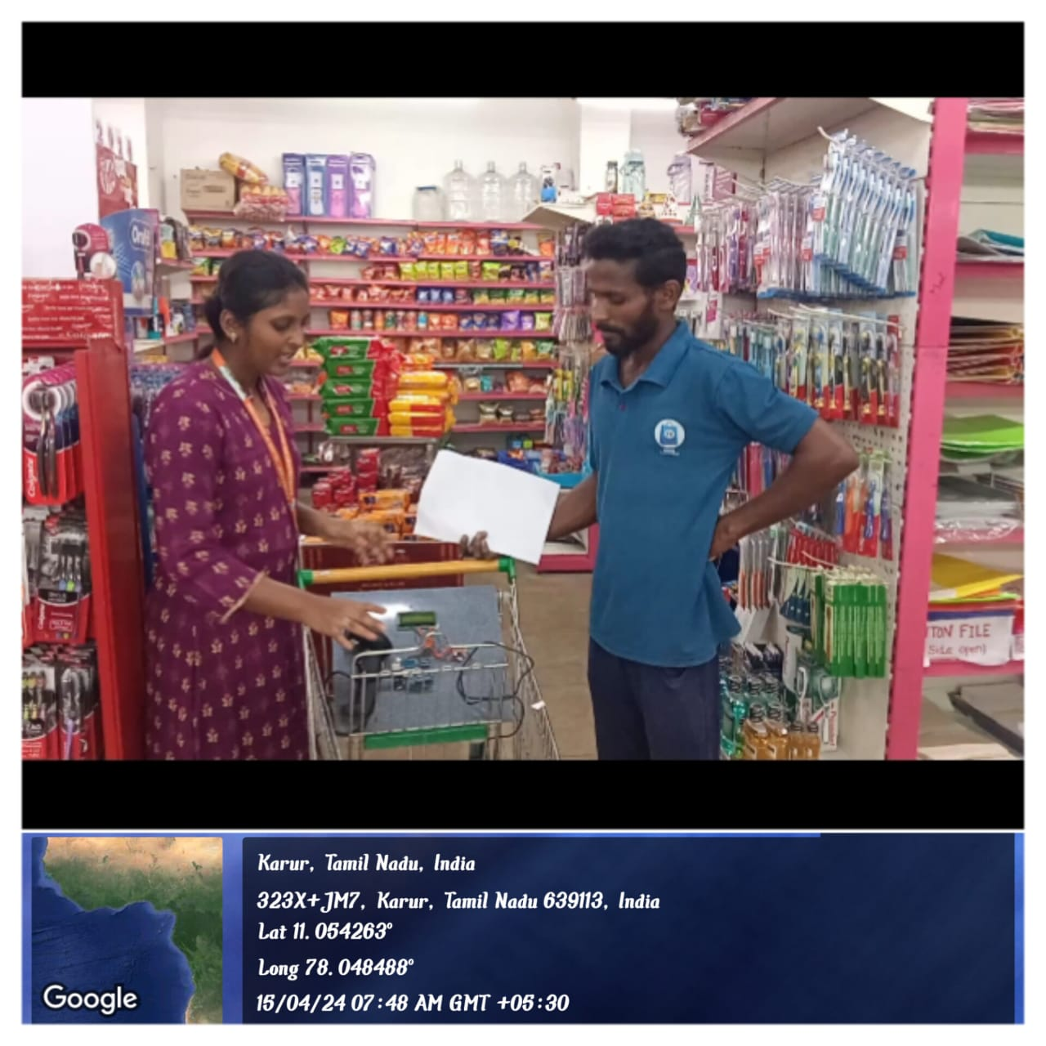

REFERENCE :

- 1) Prasiddhi K, Dhanashree H. Gawali, Innovative shopping cart for smart cities”, 2017 2nd IEEE International Conference On Recent Trends in Electronics Information & Communication Technology (RTEICT), May 19-20, 2017.

2) R. R. Vallabhuni, S. Lakshmanachari, G. Avanthi, and V. Vijay, ”Smart CartShopping free and extensible software through C ++ libraries, free and extensible hardware.

- System with an RFID Interface for Human Assistance'', 2020 3rdInternational Conference on Intelligent Sustainable Systems (ICISS), 2020.

- 3) S. Mekruksavanich, ”Design and Implementation of the Smart ShoppingBasket Based on IoT Technology”, 2019 14th International Joint Symposiumon Artificial Intelligence and Natural Language Processing (Isai NLP), 2019.

- 4) Yathisha, L., Abhishek, A., Harshith, R., Darshan Koundinya,S.R., Srinidhi, K.,
“Automation of shopping carts to ease queues in malls byusing RFID” (2015)

- 5) Karpagam, V., Balapriya, S., Kalairubini, G., & Kalaivani, “Smart trolley with smart billing. International Journal of Computer Systems.” (2017)

Guide line for implementation process

Step 1:
ADRUINO BOARD:
Arduino board setting first the input is given to the adruino the implement the coding process for counting the amount the arduino simplifies the work with microcontorllers by simple programming enivorment thorugh c++ programming .

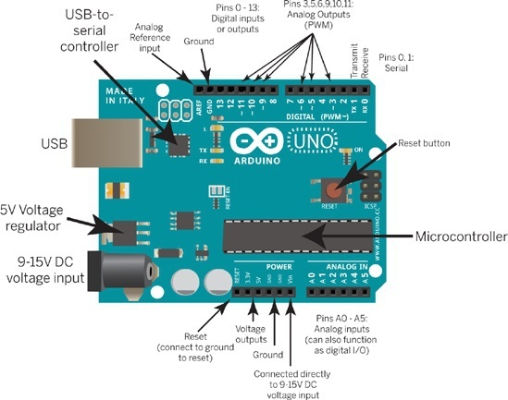
Step 2:

Pin configuration :
There are 32 pins in arduino to process the input signal of the program coded in the kit .Each has a different operating operation of the system depends upon the program is encoded to the system .after that when the input signal its operates according to that program implementation.
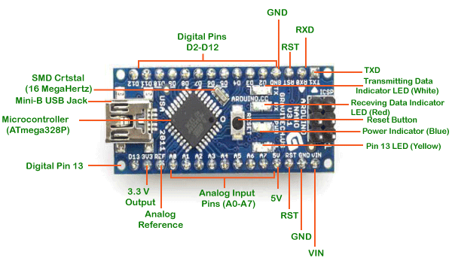

Step 3:
QR CODE SCANNER :
The scanners scans the amount and serial no of the product using scanner code and this input if given to arduino board pin by a serial connection .The scanner adapter is get connected to the arduino board connection and it implements the next processes.and it stores the input in the arduino.

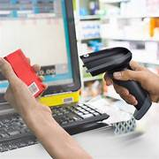

Step 4:
LCD DISPLAY:
The lcd display gives the ouput of the system which shows the serial no and exact amount of the product . which is already programmed to the lcd display thorugh c programming for supply on processes at 5v supply .

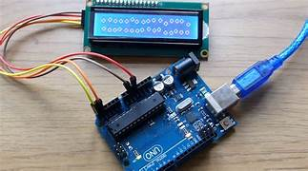

Step 6:

Final output of system :
The first input is given to arduino board when we scans the product and the scanner input is implemented to the arduino and the arduino process by the program and the processed input is given to the lcd display which is already embeded by the program and the lcd display shows the amount and serial no of the product in the trolley theses components were fixed in trolley for customer users to know the exact amount of the product and total products taken by the customers. If the product is removed from trolley the values changes in lcd display automatically.

